
2026-27 Elementary School Supply List

Backpack without wheels (K-5)
Earbuds or headphones (K-5)
2 two-pocket folders (K-5)
Pencil Pouch (K-2)
2 boxes of 24 count crayons (K-2)
1 box of 12 count #2 pencils (1-5)
1 box of 12 count colored pencils (3-5)
1 box of markers (3-5)
2 glue sticks (K-5)
2 highlighters (K-5)
Erasers (K-5)

Optional: Stylus for iPad



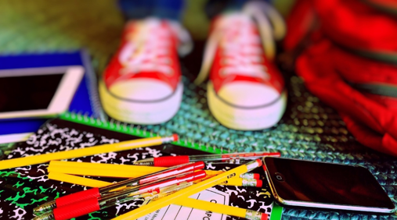

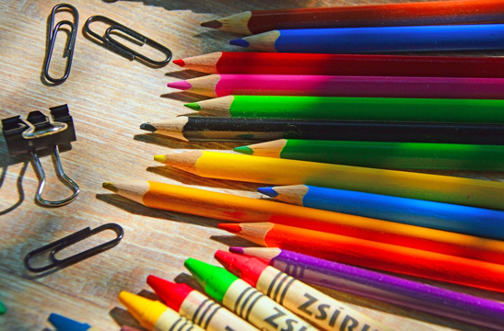

The following donations are always appreciated:
Any of the items on the list above
Dry erase markers
Small glue bottles
Tissues
Hand sanitizer

Donation Notes
Each elementary school will place a donation box inside the front
entrance of the school.
Summer hours are 9:00 am – 2:00 pm, Monday through Thursday through August 9th.
Donations will be accepted through August 23, 2026

